Shturmann | Category 5e U/UTP AWG24 PVC
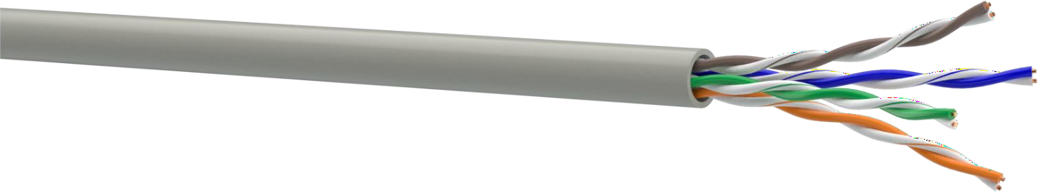
- Conductor: soft copper wire AWG24 (Ø 0,51 mm)  - Insulation: HDPE, Ø 0,89 mm  - Pair: two conductors twisted together Color identification of pairs:  pair 1: white-blue / blue  pair 2: white-orange / orange pair 3: white-green / green pair 4: white-brown / brown  - Jacket: PVC, thickness 0,5 mm, nominal cable Ø 4,8 mm | DESIGN  1  2  3  4
APPLICATION |  |  | INSTALLATION AND OPERATION CONDITIONS
- PBX, V.11, X.21, ISDN, Ethernet (10Base-T), ATM-25/52/155 Mbit/s, 100VG-AnyLAN, Token Ring 16/100 Mbit/s  - Fast Ethernet (100BASE-TX), Gigabit Ethernet (1000BASE-T), 2,5 Gbit/s Ethernet (2.5GBASE-T) and 5 Gbit/s (5GBASE-T) with a Channel length of 100 meters confirmed  - PoE, PoE+, PoE++ |  |  | For stationary installation inside buildings, stations, structures and equip- ment. Operated on frequencies up to 100 MHz
СOMPLIANCE WITH THE REQUIREMENTS |  |  | MECHANICAL CHARACTERISTICS
Cabling: ISO/IEC 11801-1, EN 50173-1, ANSI/TIA-568.2-D  Cable: IEC 61156-5, EN 50288-3-1, ANSI/TIA-568.2-D  CPR euroclass: Eca |  |  | Temperature range:  - During installation -10 °C ... +60 °C  - After installation -20 °C ... +60 °C  Bending radius:  - During installation ≥ 8 cable diameters  - After installation ≥ 4 cable diameters  Tensile stress: ≤ 85 N
ELECTRICAL CHARACTERISTICS AT 20 °C, 100 M
Parameter | Unit |  | Value
Capacitance | pF/m |  | ≤ 56
Direct current resistance | Оhm/km |  | ≤ 93
Insulation resistance | GOhm/km |  | ≥ 5
Resistance unbalance | % |  | 2
Signal propagation velocity | s |  | 0,68
Propagation delay | ns/100 m |  | ≤ 534+36/√f
Delay shift on the frequency 100 MHz | ns/100 m |  | ≤ 30
Characteristic impedance in the frequency range of:  1-250 MHz | Ohm |  | 100±15
Test voltage between cores, (DC, 2 s) | kV |  | 2,5
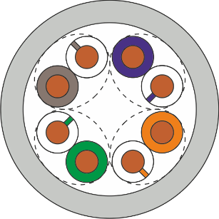
TRANSMISSION CHARACTERISTICS AT 20 °C, 100 M

Frequency, MHz | 1 | 4 | 10 | 16 | 20 | 31,25 | 62,5 | 100 | 250
Attenuation, dB, max | 2,1 | 3,8 | 6 | 7,6 | 8,5 | 10,8 | 15,5 | 19,9 | 33
NEXT, dB, min | 75,3 | 66,3 | 60,3 | 57,3 | 55,8 | 52,8 | 48,3 | 45,3 | 39,3
PS NEXT, dB, min | 72,3 | 63,3 | 57,3 | 54,3 | 52,8 | 49,8 | 45,3 | 42,3 | 36,3
ELFEXT, dB, min | 68 | 56 | 48 | 44 | 42 | 38 | 32 | 28 | 20
PS ELFEXT, dB, min | 65 | 53 | 45 | 41 | 39 | 35 | 29 | 25 | 17
RL, dB, min | 20,0 | 23,0 | 25,0 | 25,0 | 25,0 | 23,6 | 21,5 | 20,1 | 17,3
IEC 61156-5, values lower than 4 MHz are given for information only

